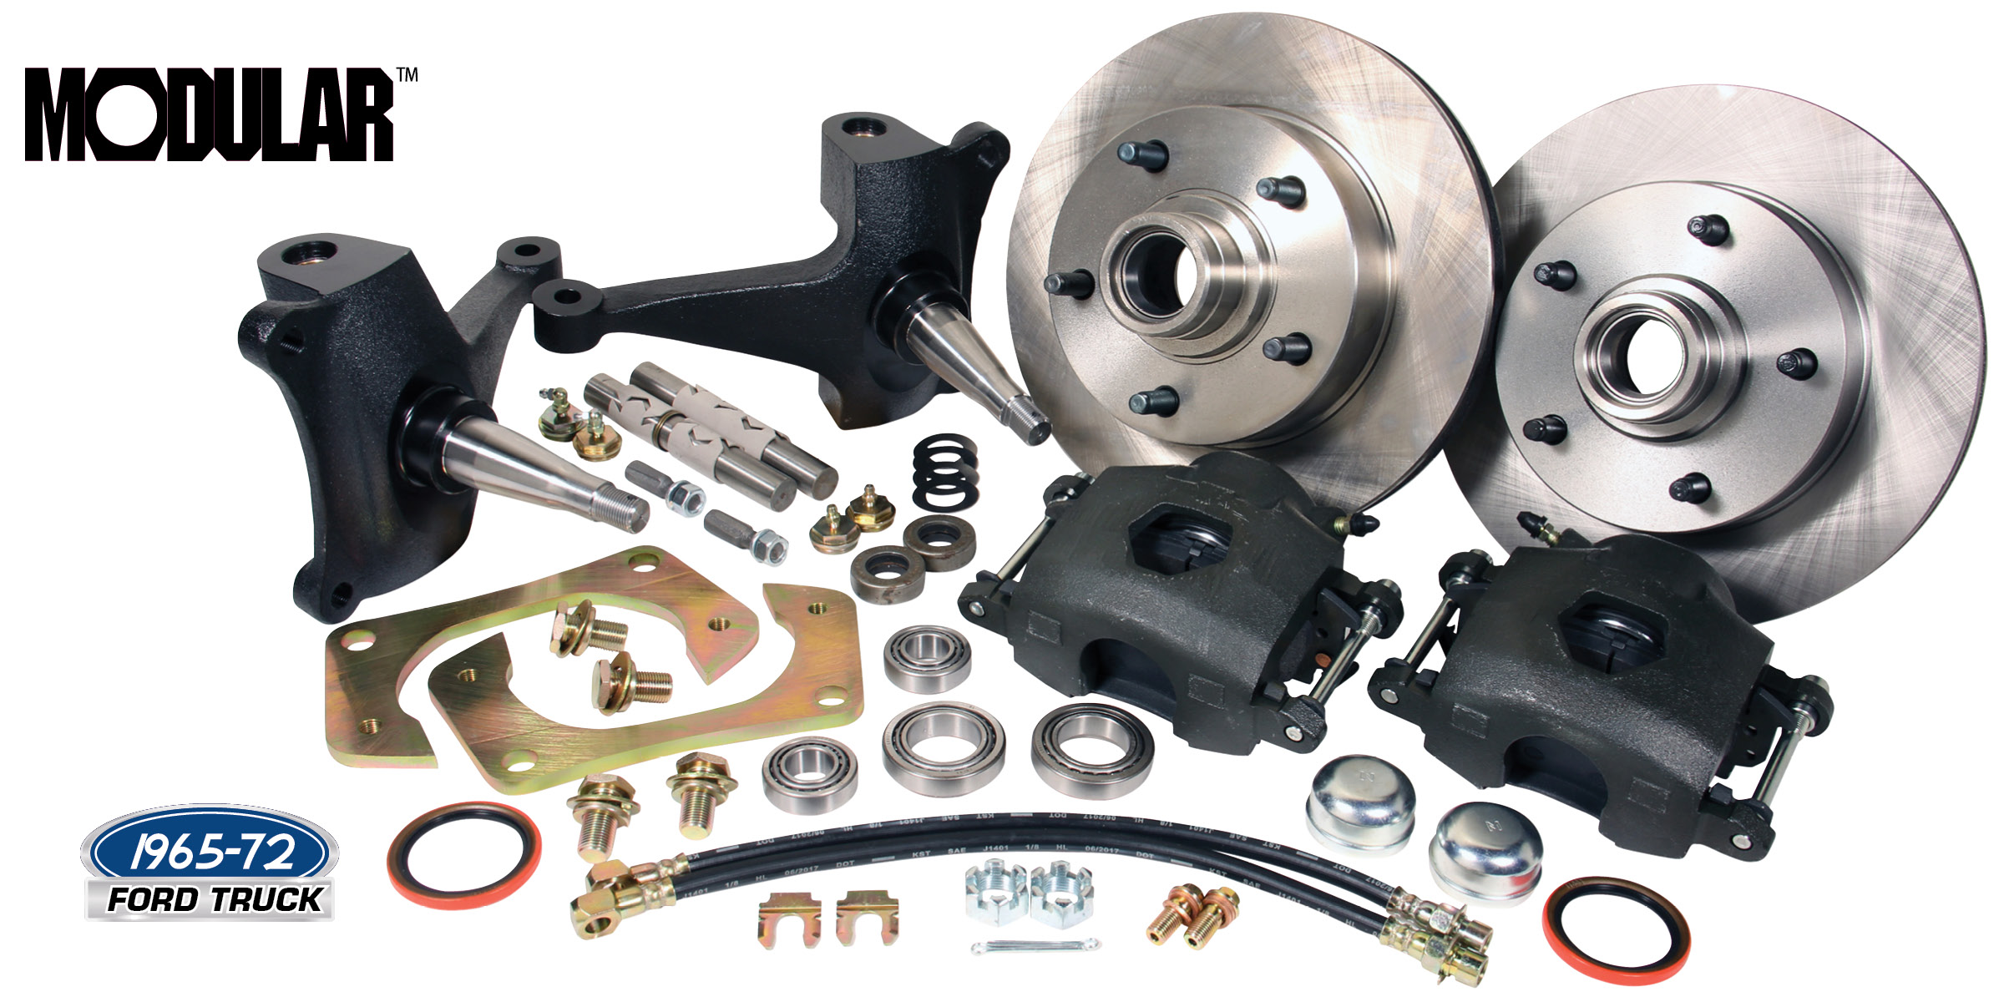

1965-72 Ford Trucks
Modular™ Stock Spindle 12” Wheel Brake Kits

CPP’s new Modular Ford Truck Spindle Brake kits are finally here, making converting to a newer, more modern disc brakes, bolt-on easy for 1965-72 Ford Trucks! These kits feature modular spindles, 12” rotors, big single piston loaded full floating calipers, new king pins and all the hoses, bearings and seals needed to complete the installation. These kits are the perfect way to rebuild your Ford Truck front axle and add modern disc brakes in bolt on fashion. (12” rotors are only available in the original 5 on 5-1/2 five bolt pattern). Requires 15” or larger disc brake wheels.

Classic Performance Products, Inc. has been providing top quality steering, brake and suspension components for classic Chevy and Ford cars and trucks, as well as street rods, for over two decades. Call (714) 522-2000 and order a catalog today, featuring our complete line of parts and accessories.
# # # #

