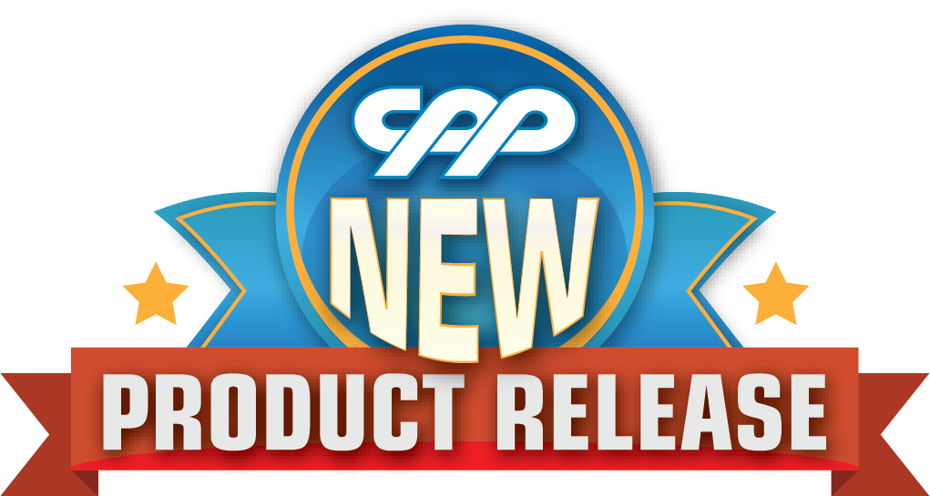
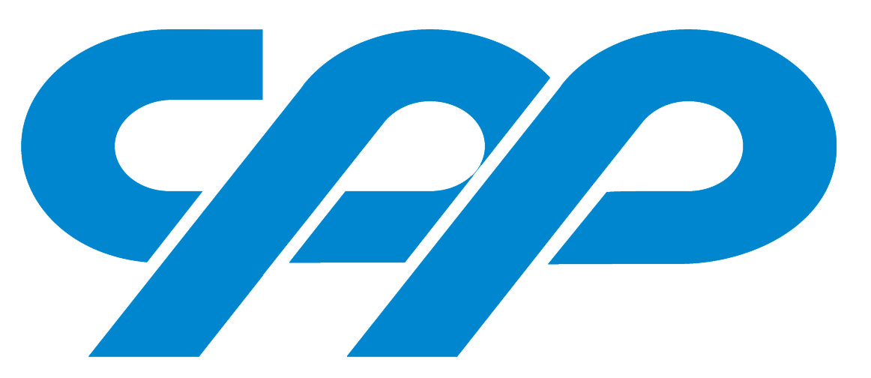
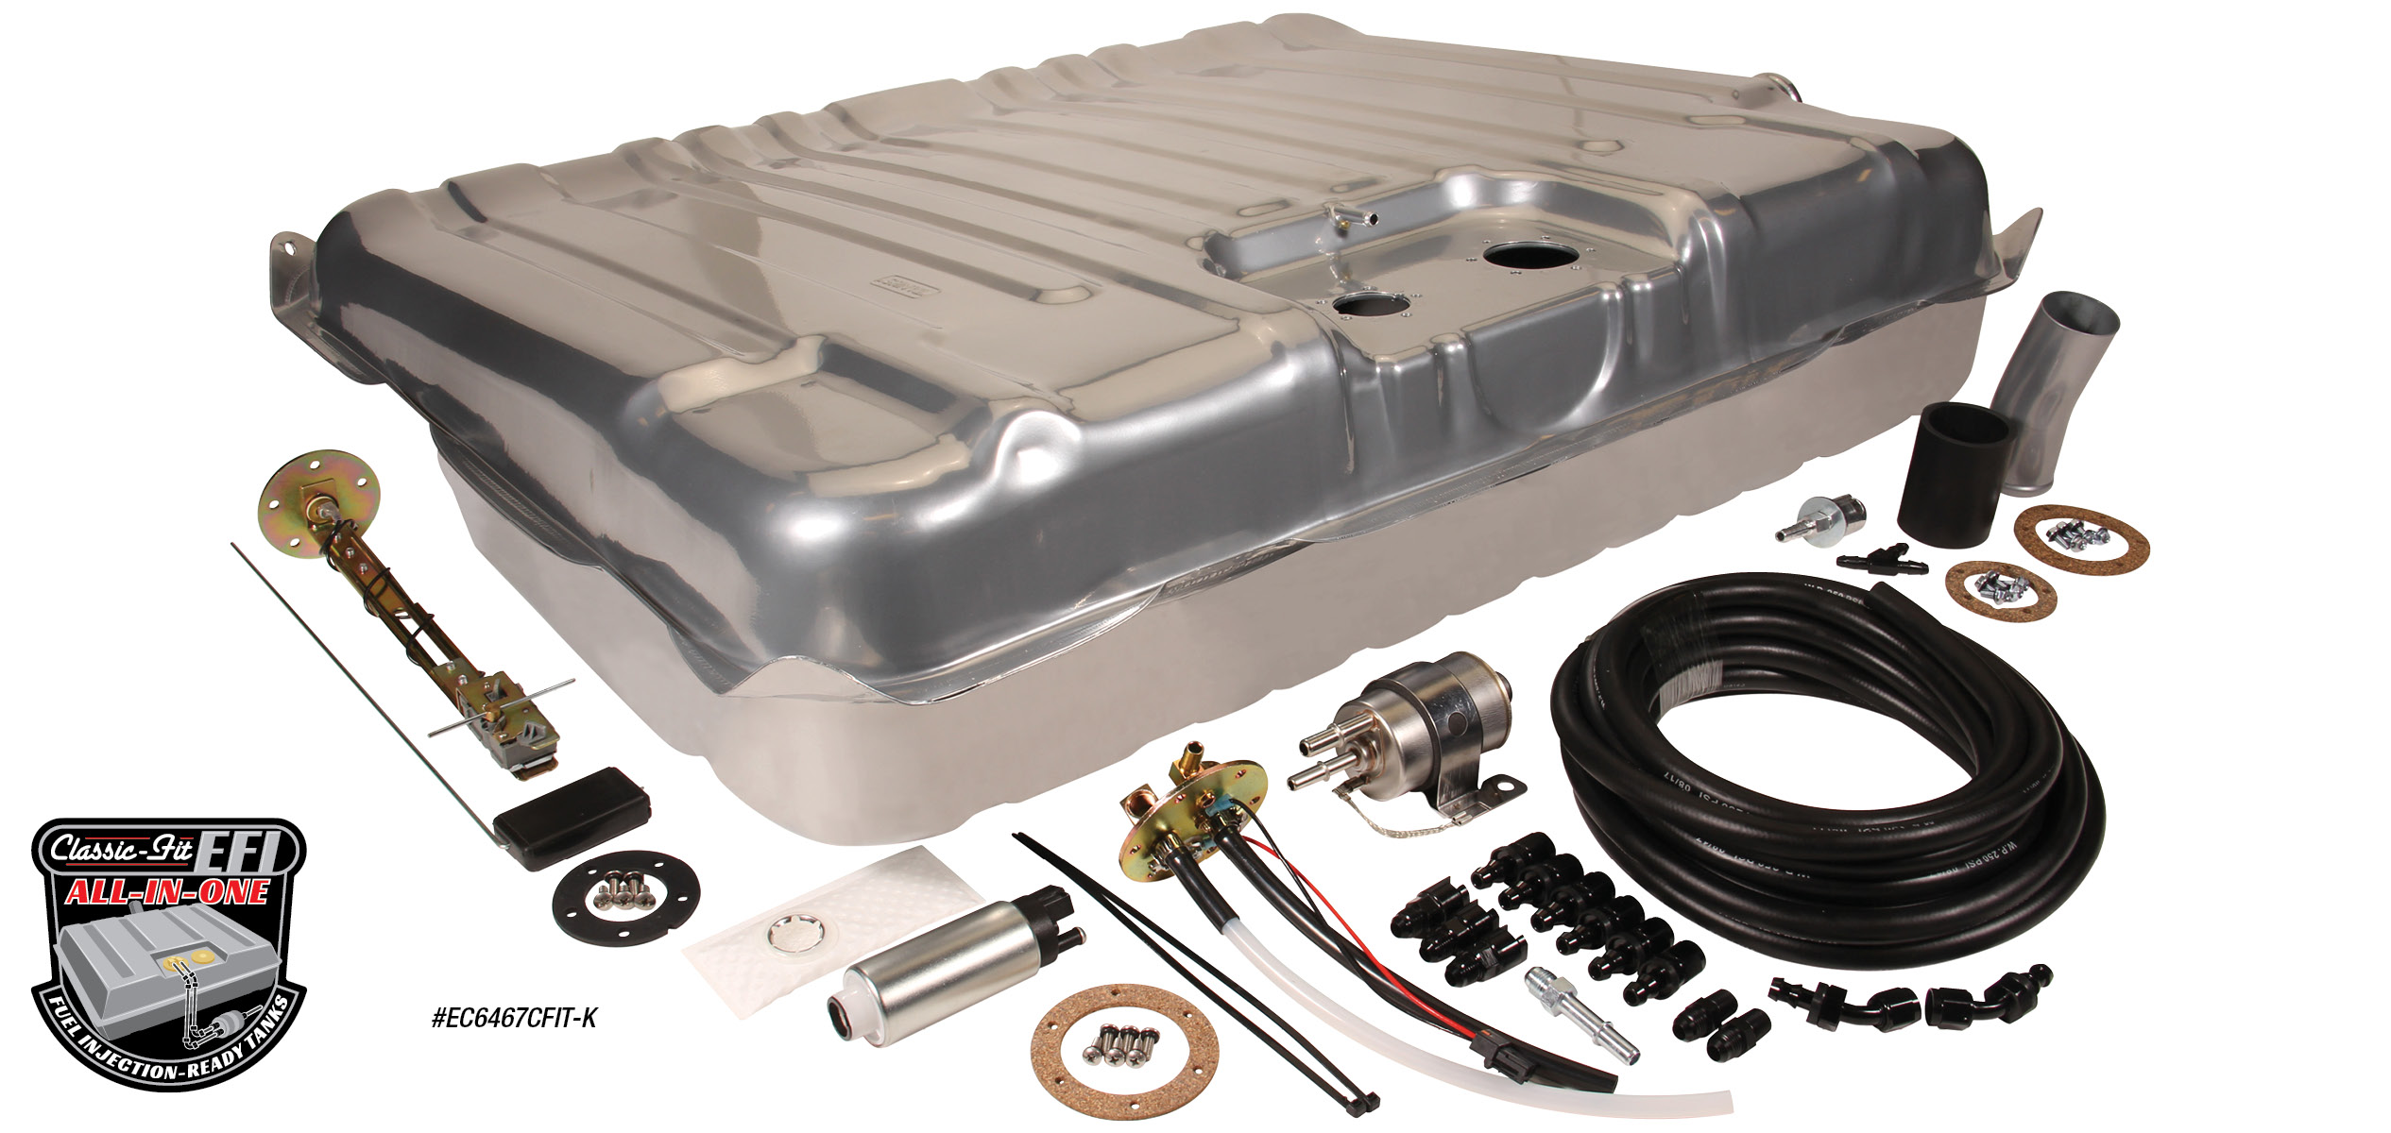
COMPLETE FUEL INJECTION-READY TANK KITS
CPP’s Complete Fuel Injection Tank Kit is the most complete choice when adding a fuel injection-ready tank to your vehicle. These kits include an original fit tank with built-in fuel tray, a fuel tank sending unit and a fuel regulator/filter combined with the most complete EFI fuel line kit in the market. This EFI Fuel Line Kit comes with the fuel hoses and all the proper -AN fittings to plumb from the fuel pump forward. CPP’s fuel fittings have a push lock connect end that does not require specialty tools to disassemble. Kits also include a 255 l/h In-tank pump that supports up to 600 HP, or an upgraded high-volume pump option, with the proper install components. In-tank pumps are much more efficient and run much cooler, and quieter, than running an inline pump. Kits contains all of the necessary pieces to mount to your vehicle. Fuel Tank Kits start at $425.00 and are available for most popular Chevrolet cars & Ford Mustangs.

Classic Performance Products, Inc. is the leading manufacturer of high quality steering, brake and suspension components for classic Chevy and Ford cars and trucks. Call (833)710-8791 and order a catalog today, featuring our complete line of parts and accessories. All CPP products come with a lifetime warranty.
# # # #

