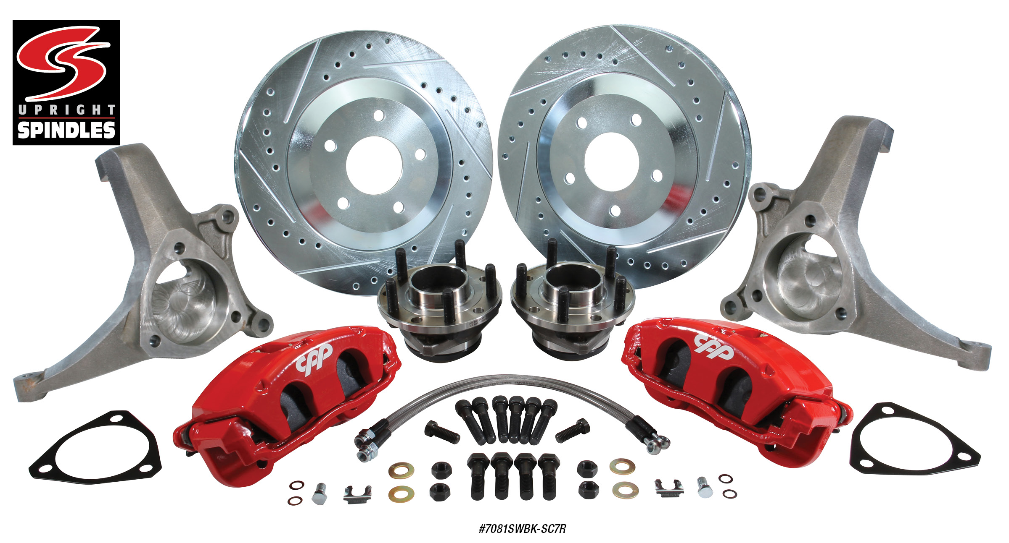

CORVETTE-STYLE SPINDLE WHEEL BRAKE KITS
CPP introduces its newest addition to the Corvette style spindle product line. CPP’s high performance
Corvette-style wheel brake kit utilizes a C7 Corvette style hub assembly, which includes heavy duty
1/2-20”x 2” screw-in wheel studs and a stronger sealed bearing pack. With a sealed bearing pack, flex on the factory spindle pin, which causes caliper piston push back is resolved. This condition is especially a problem on aftermarket multi-piston radial mount style calipers. This kit also includes our Corvette style spindles, which are a direct bolt-on for a Nova, Chevelle and Camaro (early Camaro kit uses original or CPP replacement steering arms). The early AFX body tall spindle helps with improved geometry by giving a better camber change during suspension movement and also maintains the drum brake offset. Calipers are available in black or red finish. High-Performance Corvette-Style Wheel Brake Kits start at $849.00. Corvette-Style Spindles and
C7 Corvette-Style Hubs are available separately.
Classic Performance Products, Inc. is the leading manufacturer of high quality steering, brake and suspension components for classic Chevy and Ford cars and trucks. Call (833)710-8791 and order a catalog today, featuring our complete line of parts and accessories. All CPP products come with a lifetime warranty.
# # # #

