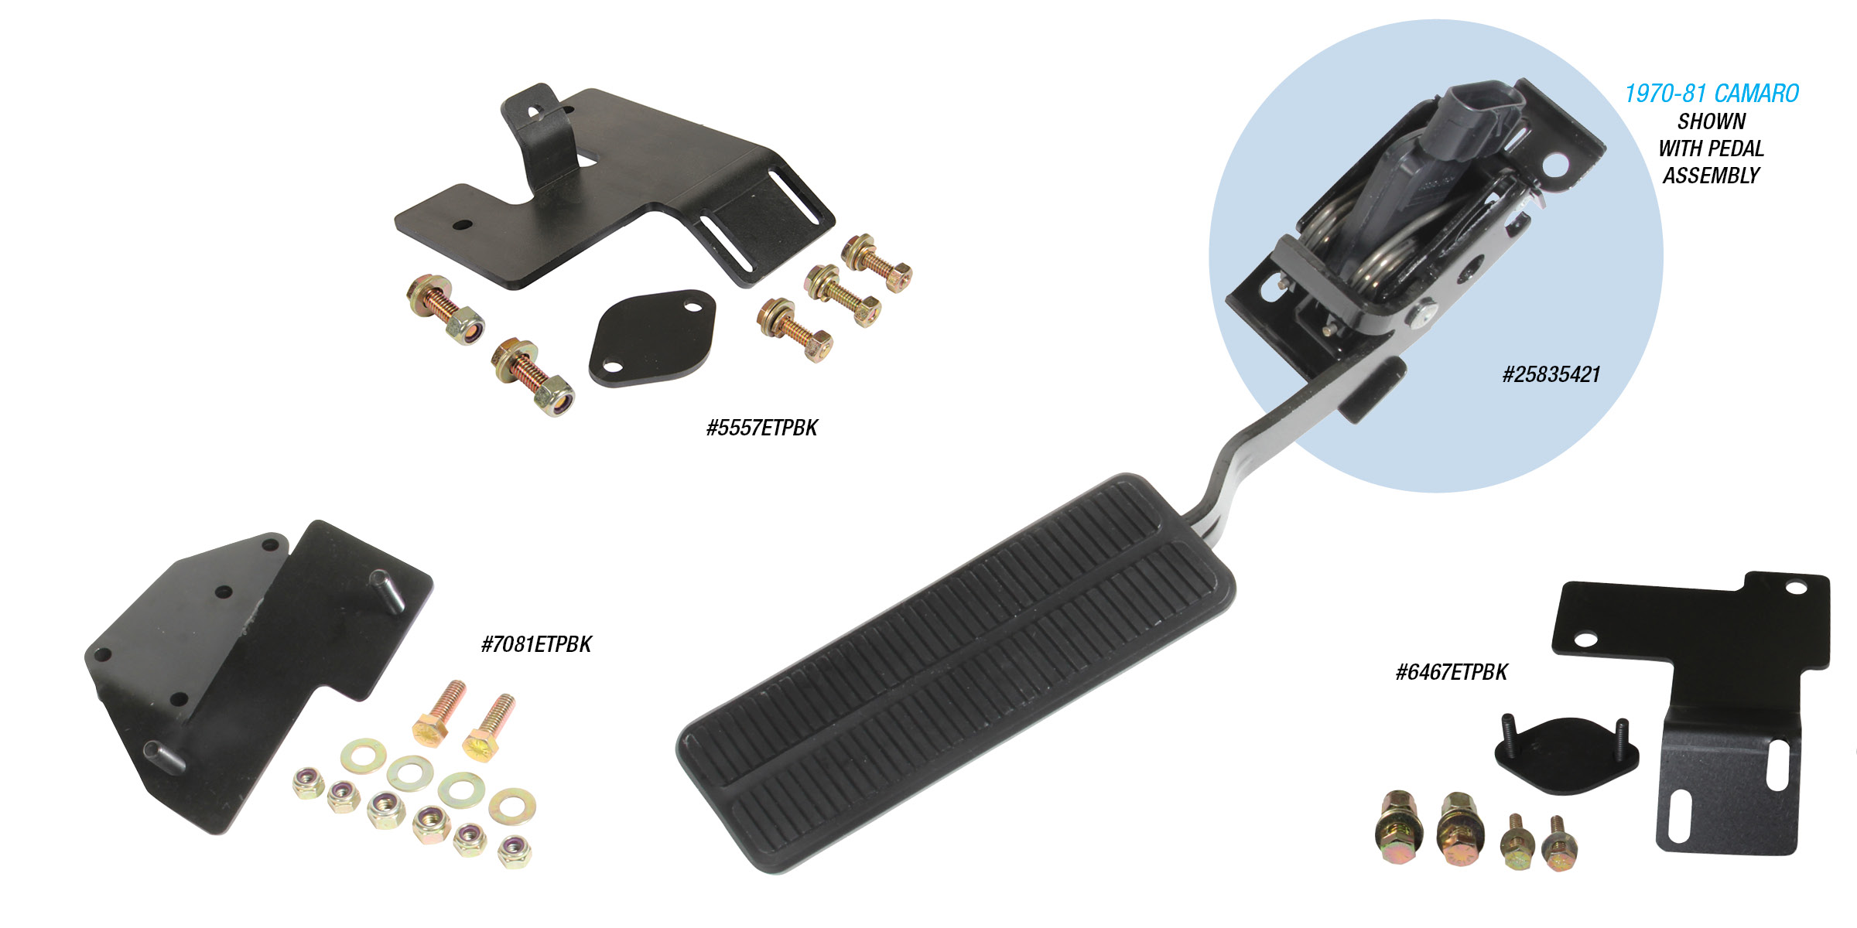

DRIVE BY WIRE THROTTLE PEDAL BRACKETS
You will no longer need to try and fabricate brackets or modify parts to mount your gas pedal when converting your classic car or truck to late model “Drive by Wire” LS Engine conversions. Late model LS Series (2003-up) have an electronic actuated throttle body verses older traditional cable actuated assemblies. All kits include a Corvette electric throttle pedal. This pedal is a direct interchange to the plastic CTS pedal included in GM crate engines. It looks the most like an original GM pedal used from the 1950’s thru the 1980’s. These conversion kits are year and model specific giving you a platform to neatly mount the included GM throttle pedal. Pedal Brackets start at $39.00. Complete assemblies with Pedal start at $139.00.
Classic Performance Products, Inc. is the leading manufacturer of high quality steering, brake and suspension components for classic Chevy and Ford cars and trucks. Call (833)710-8791 and order a catalog today, featuring our complete line of parts and accessories. All CPP products come with a lifetime warranty.
# # # #

