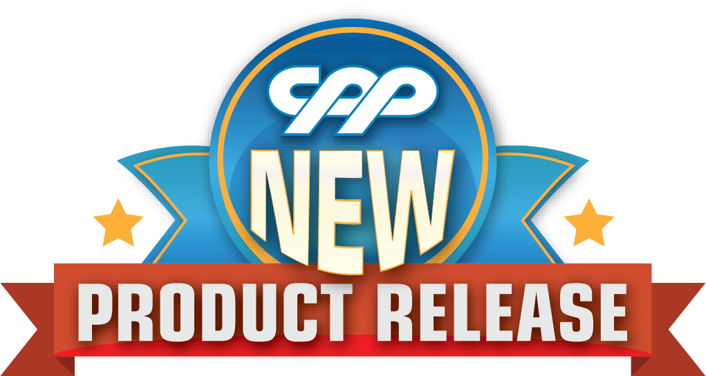

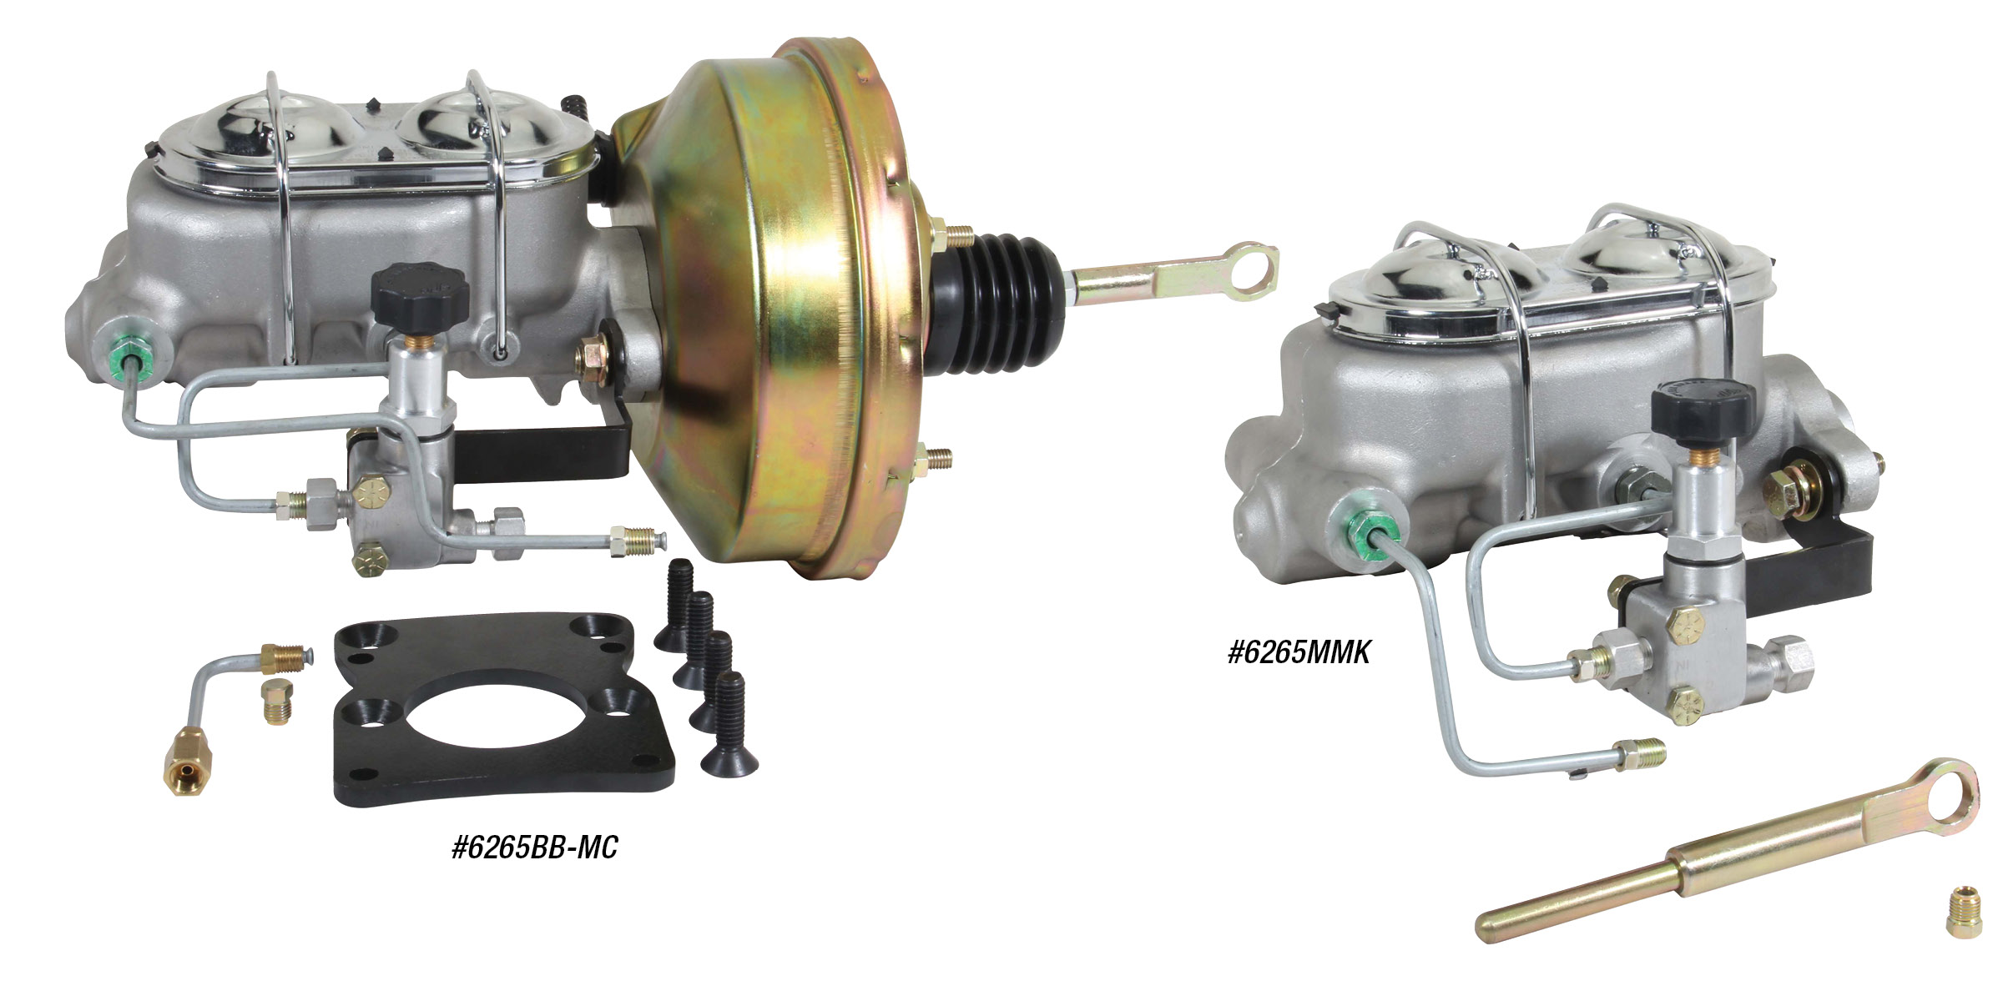

1962-1965 Ford Fairlane
Power Brake Booster Kit & Manual Brake Master Kit
CPP’s new brake booster kits work with both disc/drum and disc/disc applications, are flush mount to the firewall and use a specific designed seal to keep fumes from entering the passenger compartment. Kits feature 3/16” thick mounting brackets, pedal linkage, booster, corvette-style aluminum master cylinder, adjustable proportional valve and hardware. Also available for manual brake setups without the booster. Booster and master cylinder combos starting at $329.00, manual master and proportional valve combos starting at $189.
Classic Performance Products, Inc. is the leading manufacturer of high quality steering, brake and suspension components for classic Chevy and Ford cars and trucks. Call (833)710-8791 and order a catalog today, featuring our complete line of parts and accessories. All CPP products come with a lifetime warranty.
# # # #

