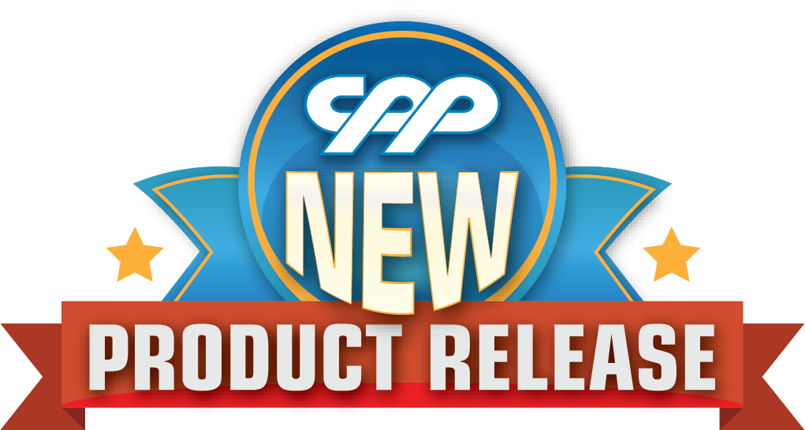
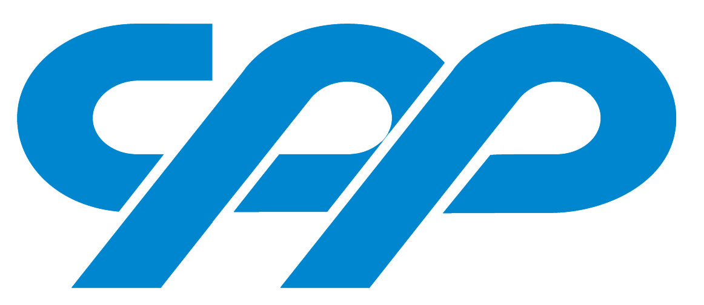

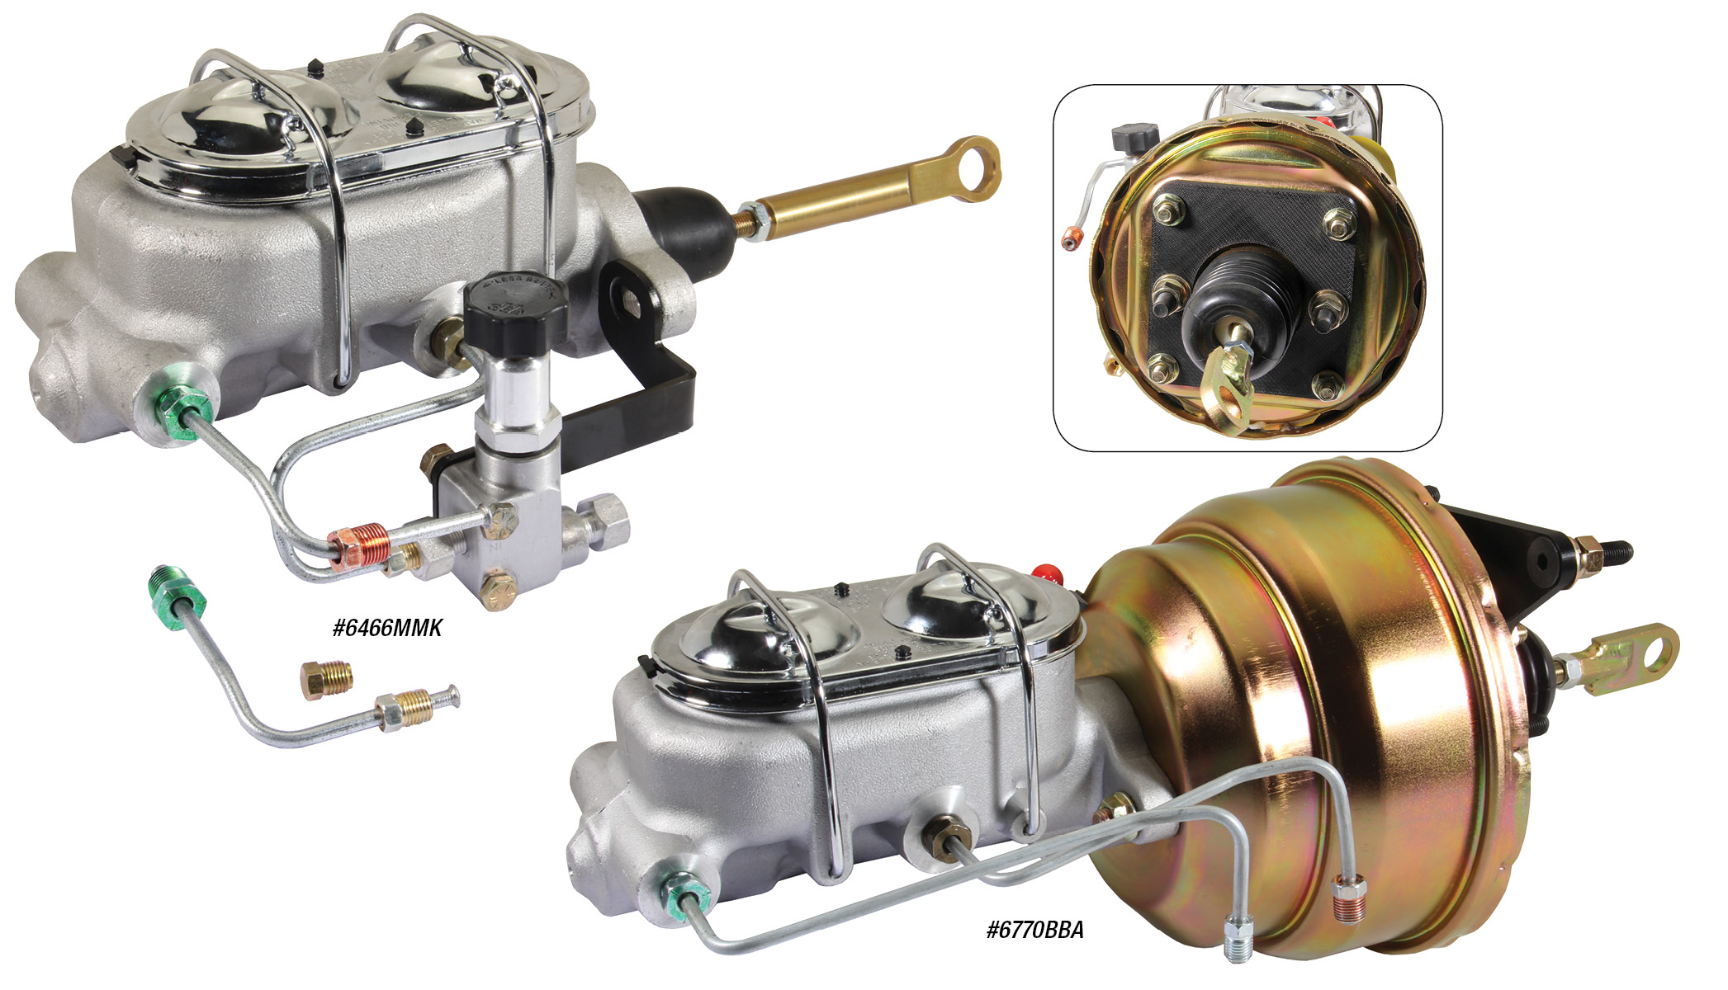

1964-70 MUSTANG BOOSTER KITS
CPP introduces our new 1964½ - 70 Mustang master cylinder and booster kits featuring a performance booster and a lightweight aluminum master cylinder with a unique bracket design that accommodates both manual and power brake firewalls. Power Brake kits are available in 7- and 8-inch diameter, single or dual, boosters for added performance.1964-66 booster kits includes an adjustable proportioning valve. Kits will not work with manual shift Mustangs with Z-Bar Linkage. Manual Booster Kits are $189.00, Power Booster Kits start at $289.00.
Classic Performance Products, Inc. is the leading manufacturer of high quality steering, brake and suspension components for classic Chevy and Ford cars and trucks. Call (833)710-8791 and order a catalog today, featuring our complete line of parts and accessories. All CPP products come with a lifetime warranty.
# # # #

