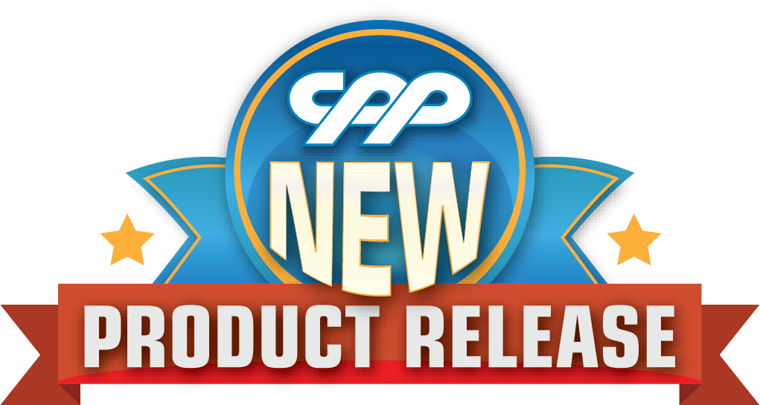
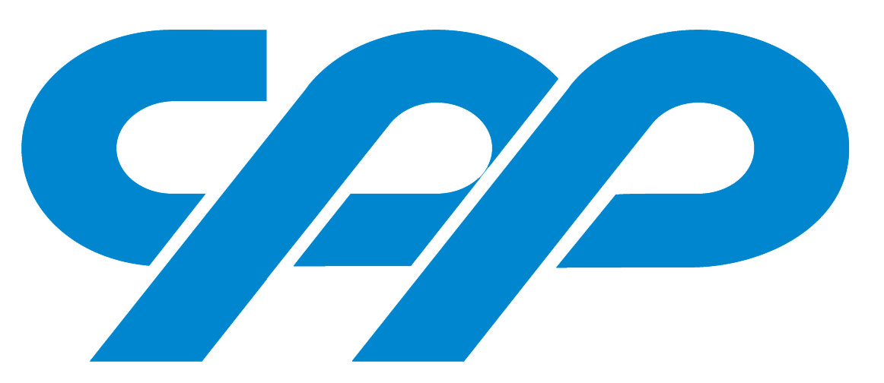
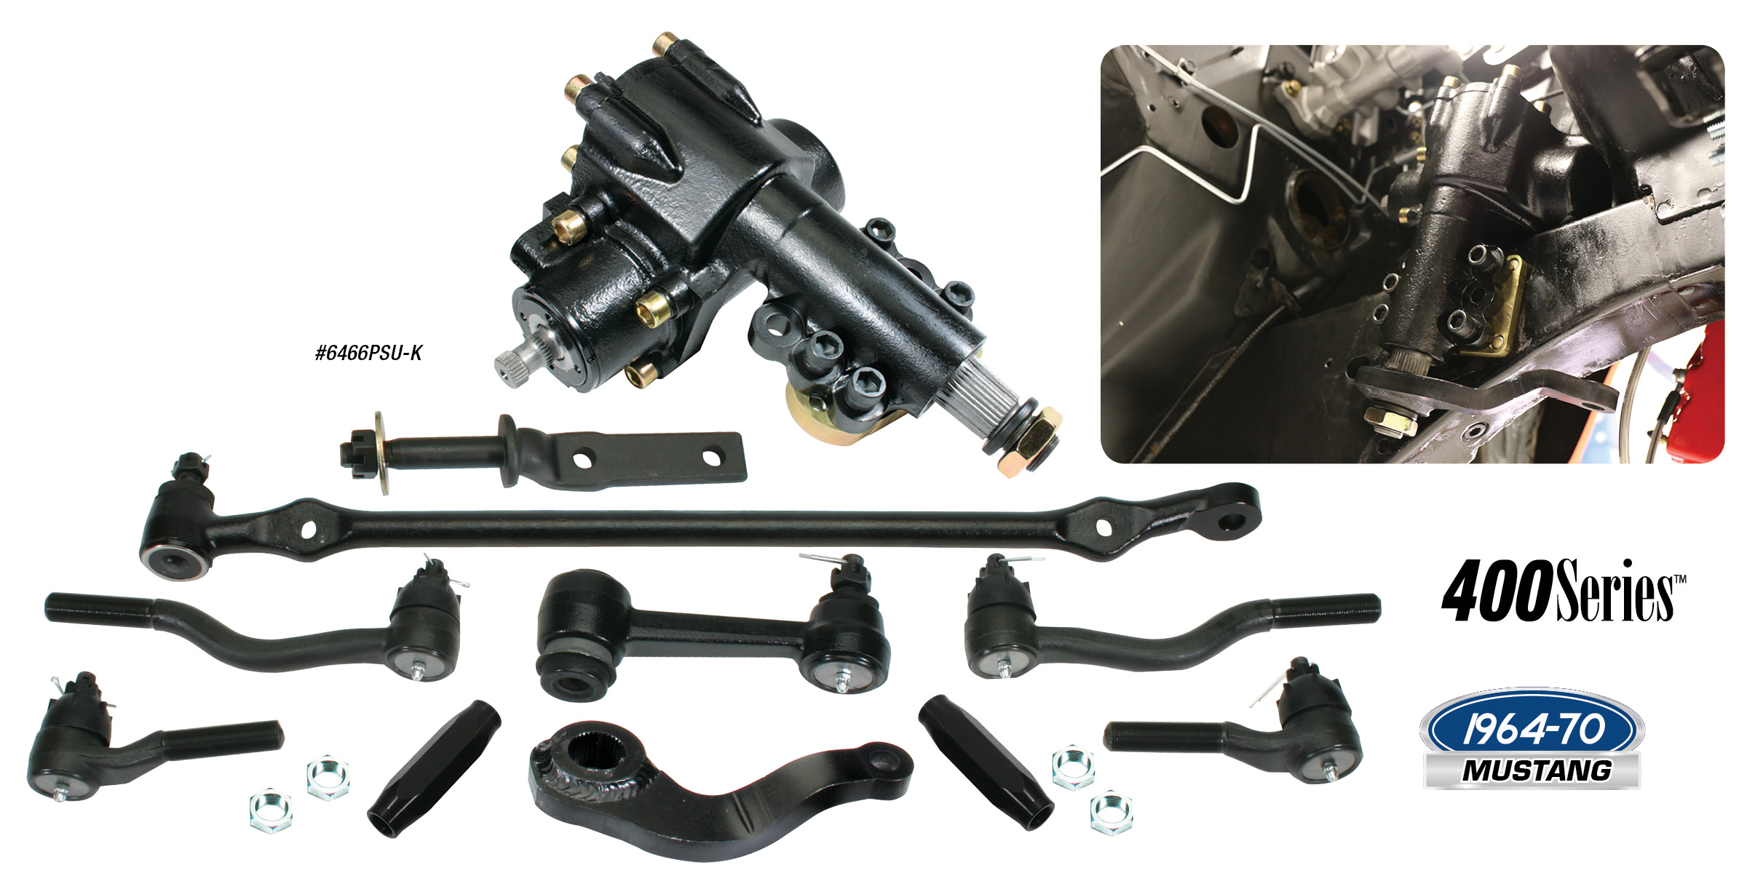

FORD MUSTANG POWER STEERING UPGRADE KITS
CPP has introduced our newest addition to our popular 400 Series™ line for 1964-70 Mustangs! This kit includes our 400 Series™ power steering box, pitman arm, inner and outer tie rod ends, center link and idler arm for an easy to install and complete power steering upgrade. This kit will easily fit in place of your factory manual steering box without modifying the firewall. CPP’s 400 Series™ power steering box is 100% brand new, with a late model style drivability, a sportier 13.6:1 ratio (best on the market!) and a better than rack and pinion feel. The improved steering linkage kit uses components designed to help prevent bumpsteer. One of the biggest improvements you can make to your Mustang’s steering! Upgrade kits are $699.00 and the individual steering
box is also available for $379.00.
Classic Performance Products, Inc. is the leading manufacturer of high quality steering, brake and suspension components for classic Chevy and Ford cars and trucks. Call (833)710-8791 and order a catalog today, featuring our complete line of parts and accessories. All CPP products come with a lifetime warranty.
# # # #

