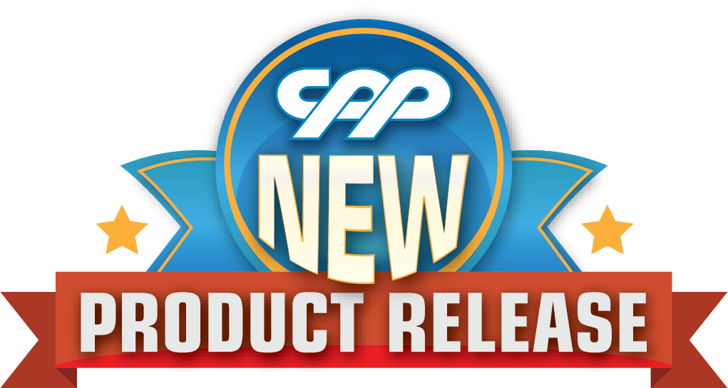

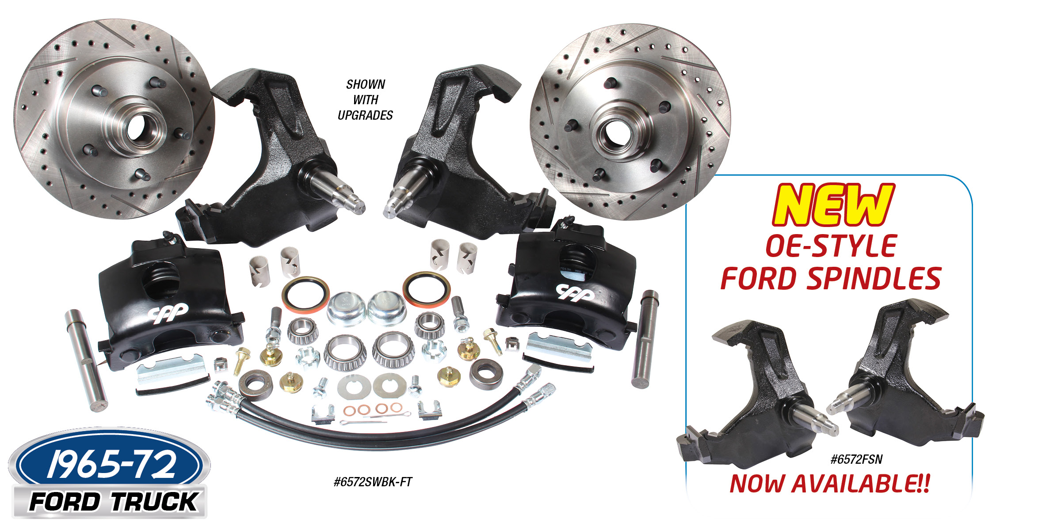

1965-72 FORD TRUCK OE STOCK SPINDLE WHEEL BRAKE KIT
No more waiting for reconditioned spindles! CPP now offers a brand new OE stock style spindle for the
1965-72 Ford trucks to make upgrading to disc conversation much easier. Our direct bolt-on kits include stock height spindles, king pin kit, 5 x 5.5 Bolt pattern rotors, calipers and mounting brackets, bearings, seals and hoses. Complete disc brake wheel kits start at $599.00. Spindles and new king pin kit also available separately to work with later F100 brake components – Spindles are $249.00 a pair.
Classic Performance Products, Inc. is the leading manufacturer of high quality steering, brake and suspension components for classic Chevy and Ford cars and trucks. Call (833)710-8791 and order a catalog today, featuring our complete line of parts and accessories. All CPP products come with a lifetime warranty.
# # # #

