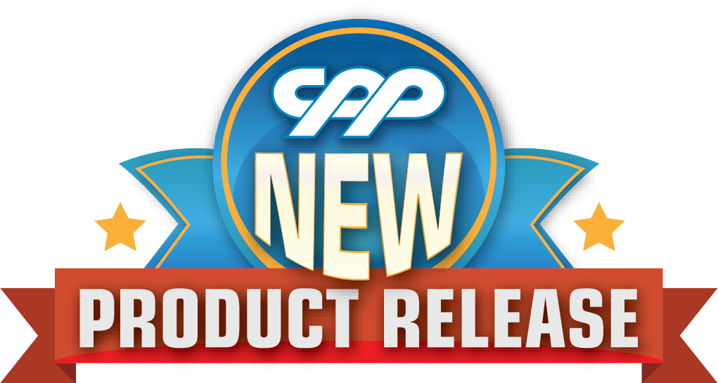
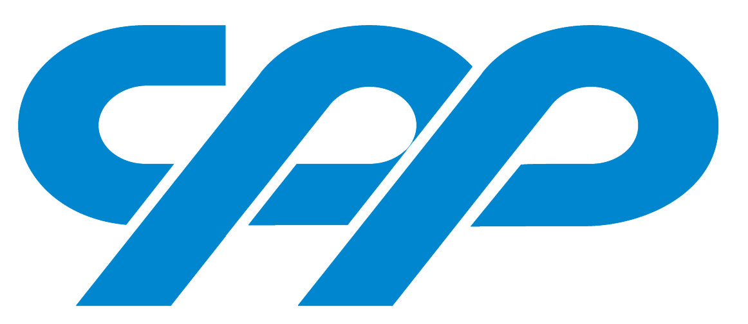

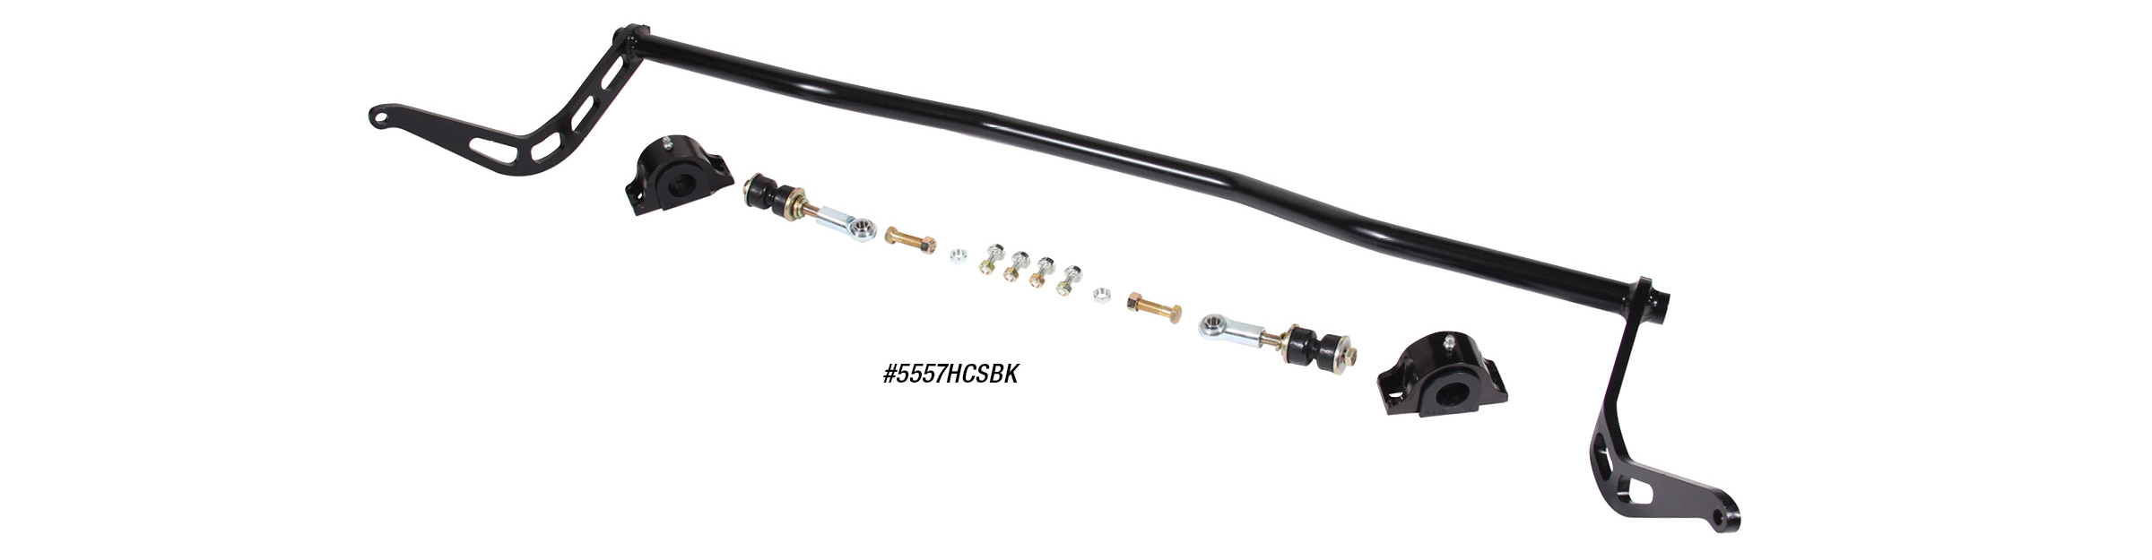

HIGH CLEARANCE FRONT SWAY BARS
CPP’s new high clearance sway bar kits feature a precision laser cut, 3/8” leg that fits tight to the chassis allowing for significantly larger front tires. This kit includes a fully adjustable heim-joint end link setup that eliminates the traditional “fixed position” style end link bushings found on traditional front sway bar kits. Using an adjustable type end link setup allows for multiple mounting positions and pre-load adjustments. The sway bar features a hollow design to reduce weight and is shorter in length for increased roll resistance. Kits are available for most
popular applications starting at $199.
Classic Performance Products, Inc. is the leading manufacturer of high quality steering, brake and suspension components for classic Chevy and Ford cars and trucks. Call (833)710-8791 and order a catalog today, featuring our complete line of parts and accessories. All CPP products come with a lifetime warranty.
# # # #

