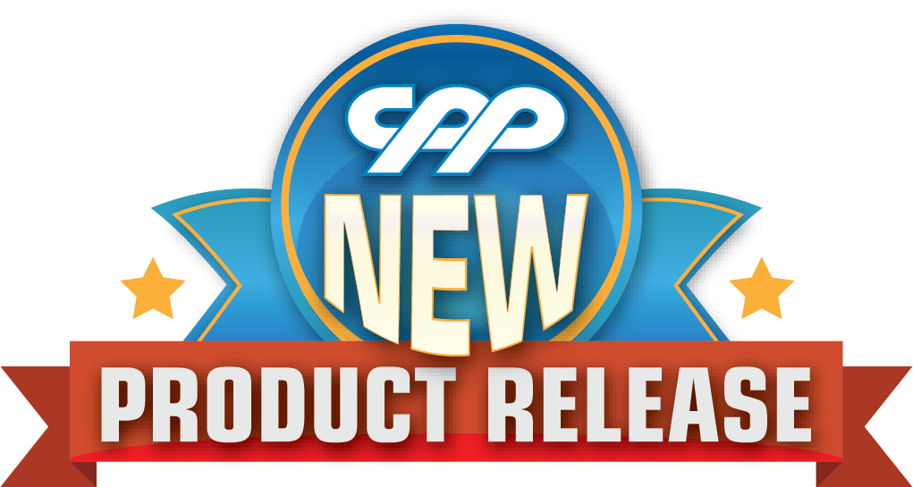
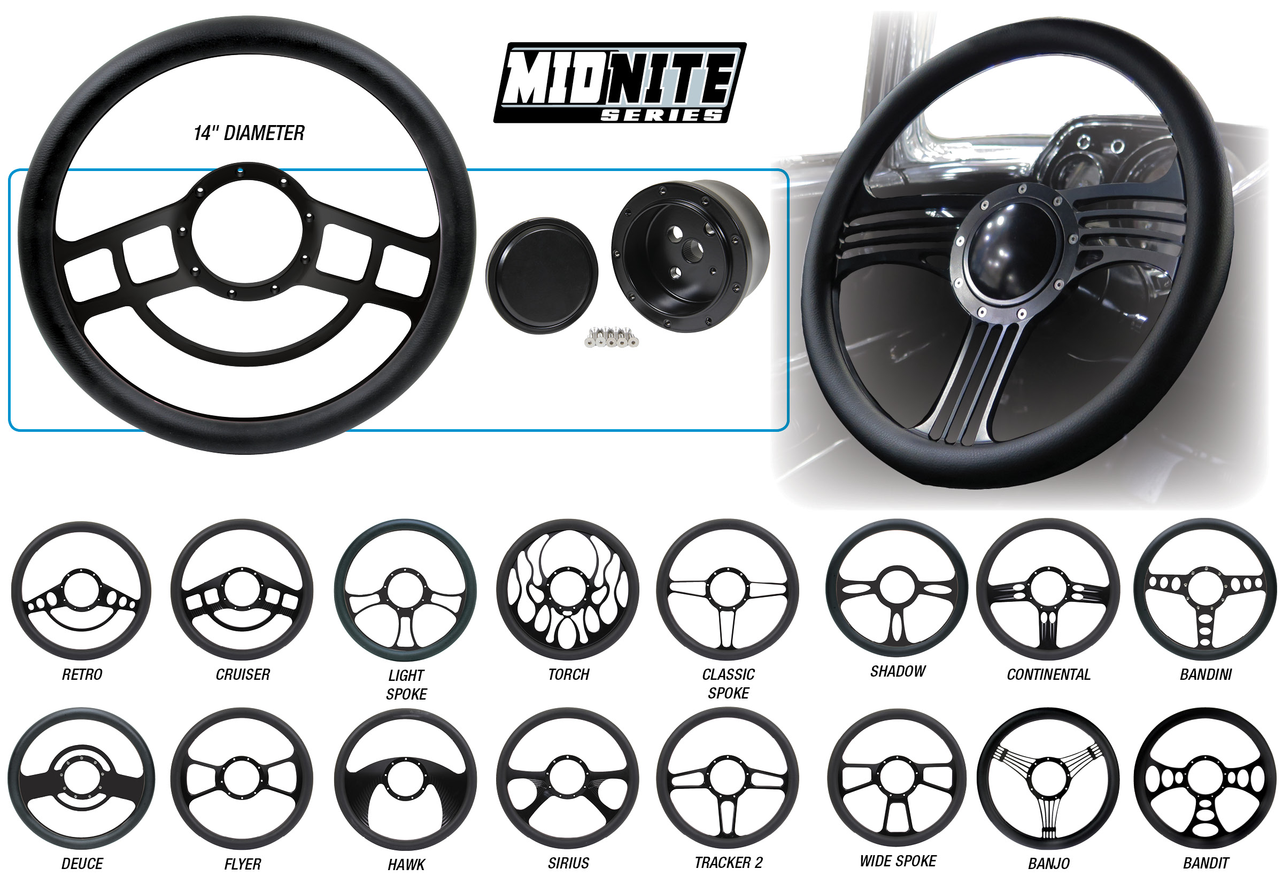

MIDNITE SERIES BILLET STEERING WHEEL PACKAGE
CPP offers our newest addition to our Midnite Series product line. Our Complete Steering Wheel package includes your choice of steering wheel, a black billet horn cap, and a black steering wheel hub adapter. These 14” steering wheels are made from black machined aluminum for a beautiful finish. Each wheel comes with a black half wrap for the ultimate finishing touch. Lots of combinations available!
Complete Steering Wheel Package is $279.00.
Classic Performance Products, Inc. is the leading manufacturer of high quality steering, brake and suspension components for classic Chevy and Ford cars and trucks. Call (833)710-8791 and order a catalog today, featuring our complete line of parts and accessories. All CPP products come with a lifetime warranty.
# # # #

