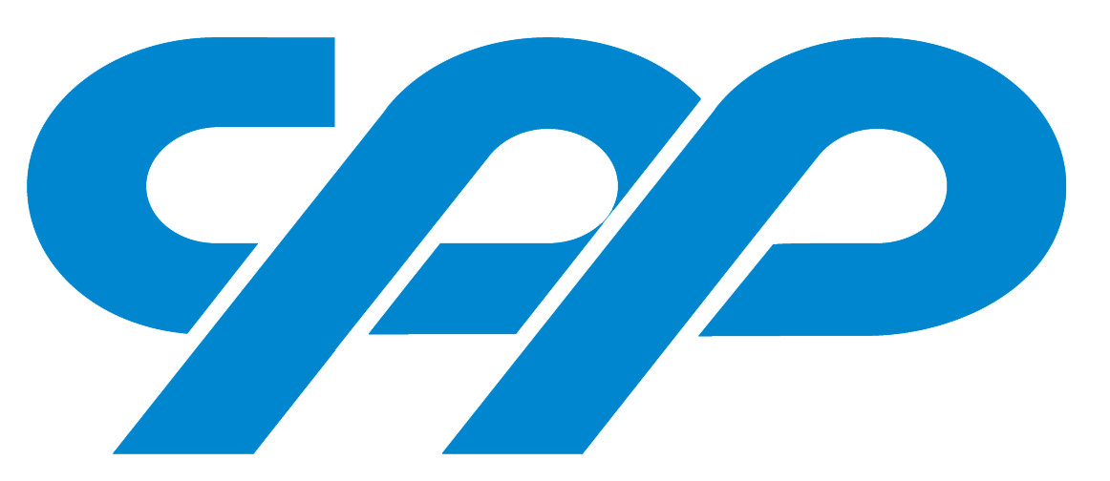

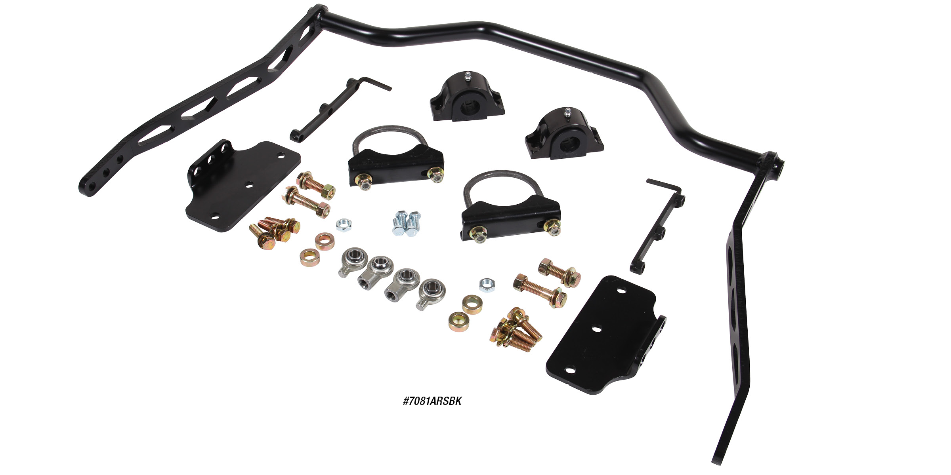

REAR ADJUSTABLE PRO-TOURING SWAY BARS
CPP’s new adjustable rear sway bar kits features billet ends welded to the center portion of the sway bar to allow for more clearance around the shock mounts. With some applications, the shocks would interfere with our Rear Pro-touring Sway bar kits. This new fully adjustable design will give you the benefits of our
Rear Pro-Touring Sway Bar kits without more space and more roll resistance. These sway bars will fit both stock and aftermarket rear ends with a 3” axle tube dimensions. Kits come complete with gloss black frame mount brackets and all the necessary hardware for an easy installation. Available for most popular application,
CPP’s new Rear Adjustable Pro-Touring Sway Bars are $199.00.
Classic Performance Products, Inc. is the leading manufacturer of high quality steering, brake and suspension components for classic Chevy and Ford cars and trucks. Call (833)710-8791 and order a catalog today, featuring our complete line of parts and accessories. All CPP products come with a lifetime warranty.
# # # #

