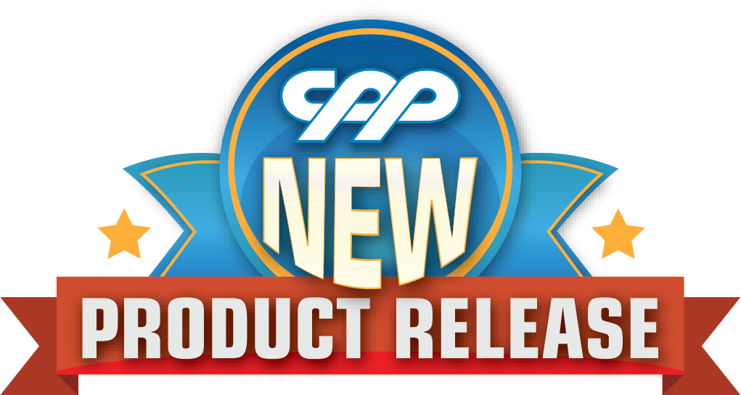
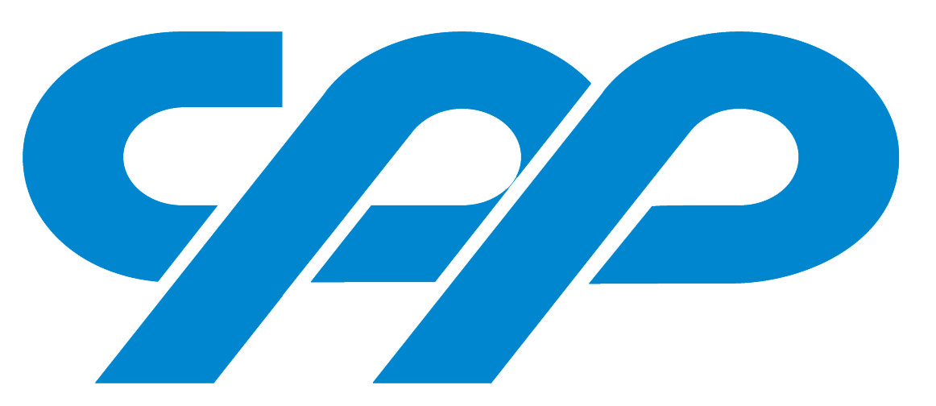

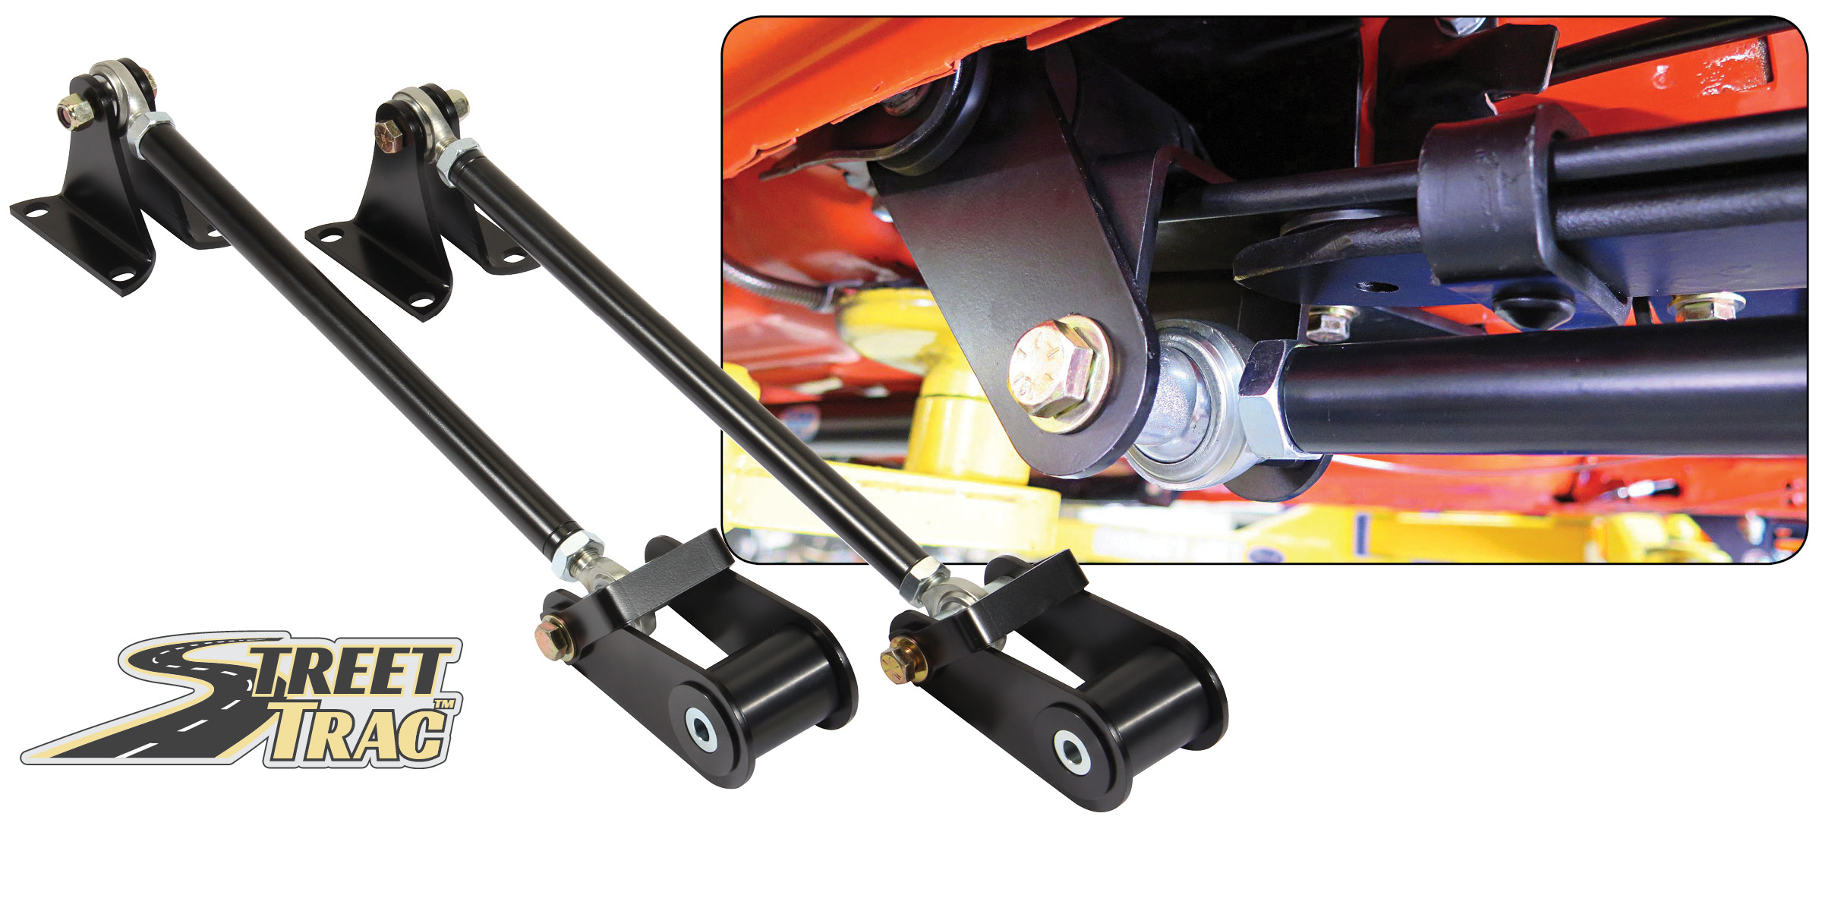

STREET-TRACTM TRACTION BARS
CPP’s new Street-TracTM traction bars - where the power meets the road! Constructed from 1" 0.156-wall 4130 (same as our Pro-Touring sway bar), with 3/16" laser-cut, bent-steel mounts and self-lubricating plastic D-type bushings (same as used in our control arms) and 3/4" rod ends. The front mount features additional ground clearance and a forward-slanted approach angle. In the event it does hit something, the angled approach will act as a skid plate and help lift the car over the obstacle. The portion of the linkage that contacts the spring is a wider flat surface; this reduces the stress on the top of the leaf spring. The pivot positions are relocated to optimize weight transfer while reducing the spring load. Available for 1955-57 Fullsize, 1962-74 Nova, 1967-81 Camaro and 1964-73 Ford Mustang. Kits starting at $299.00.

Classic Performance Products, Inc. is the leading manufacturer of high quality steering, brake and suspension components for classic Chevy and Ford cars and trucks. Call (833)710-8791 and order a catalog today, featuring our complete line of parts and accessories. All CPP products come with a lifetime warranty.
# # # #

