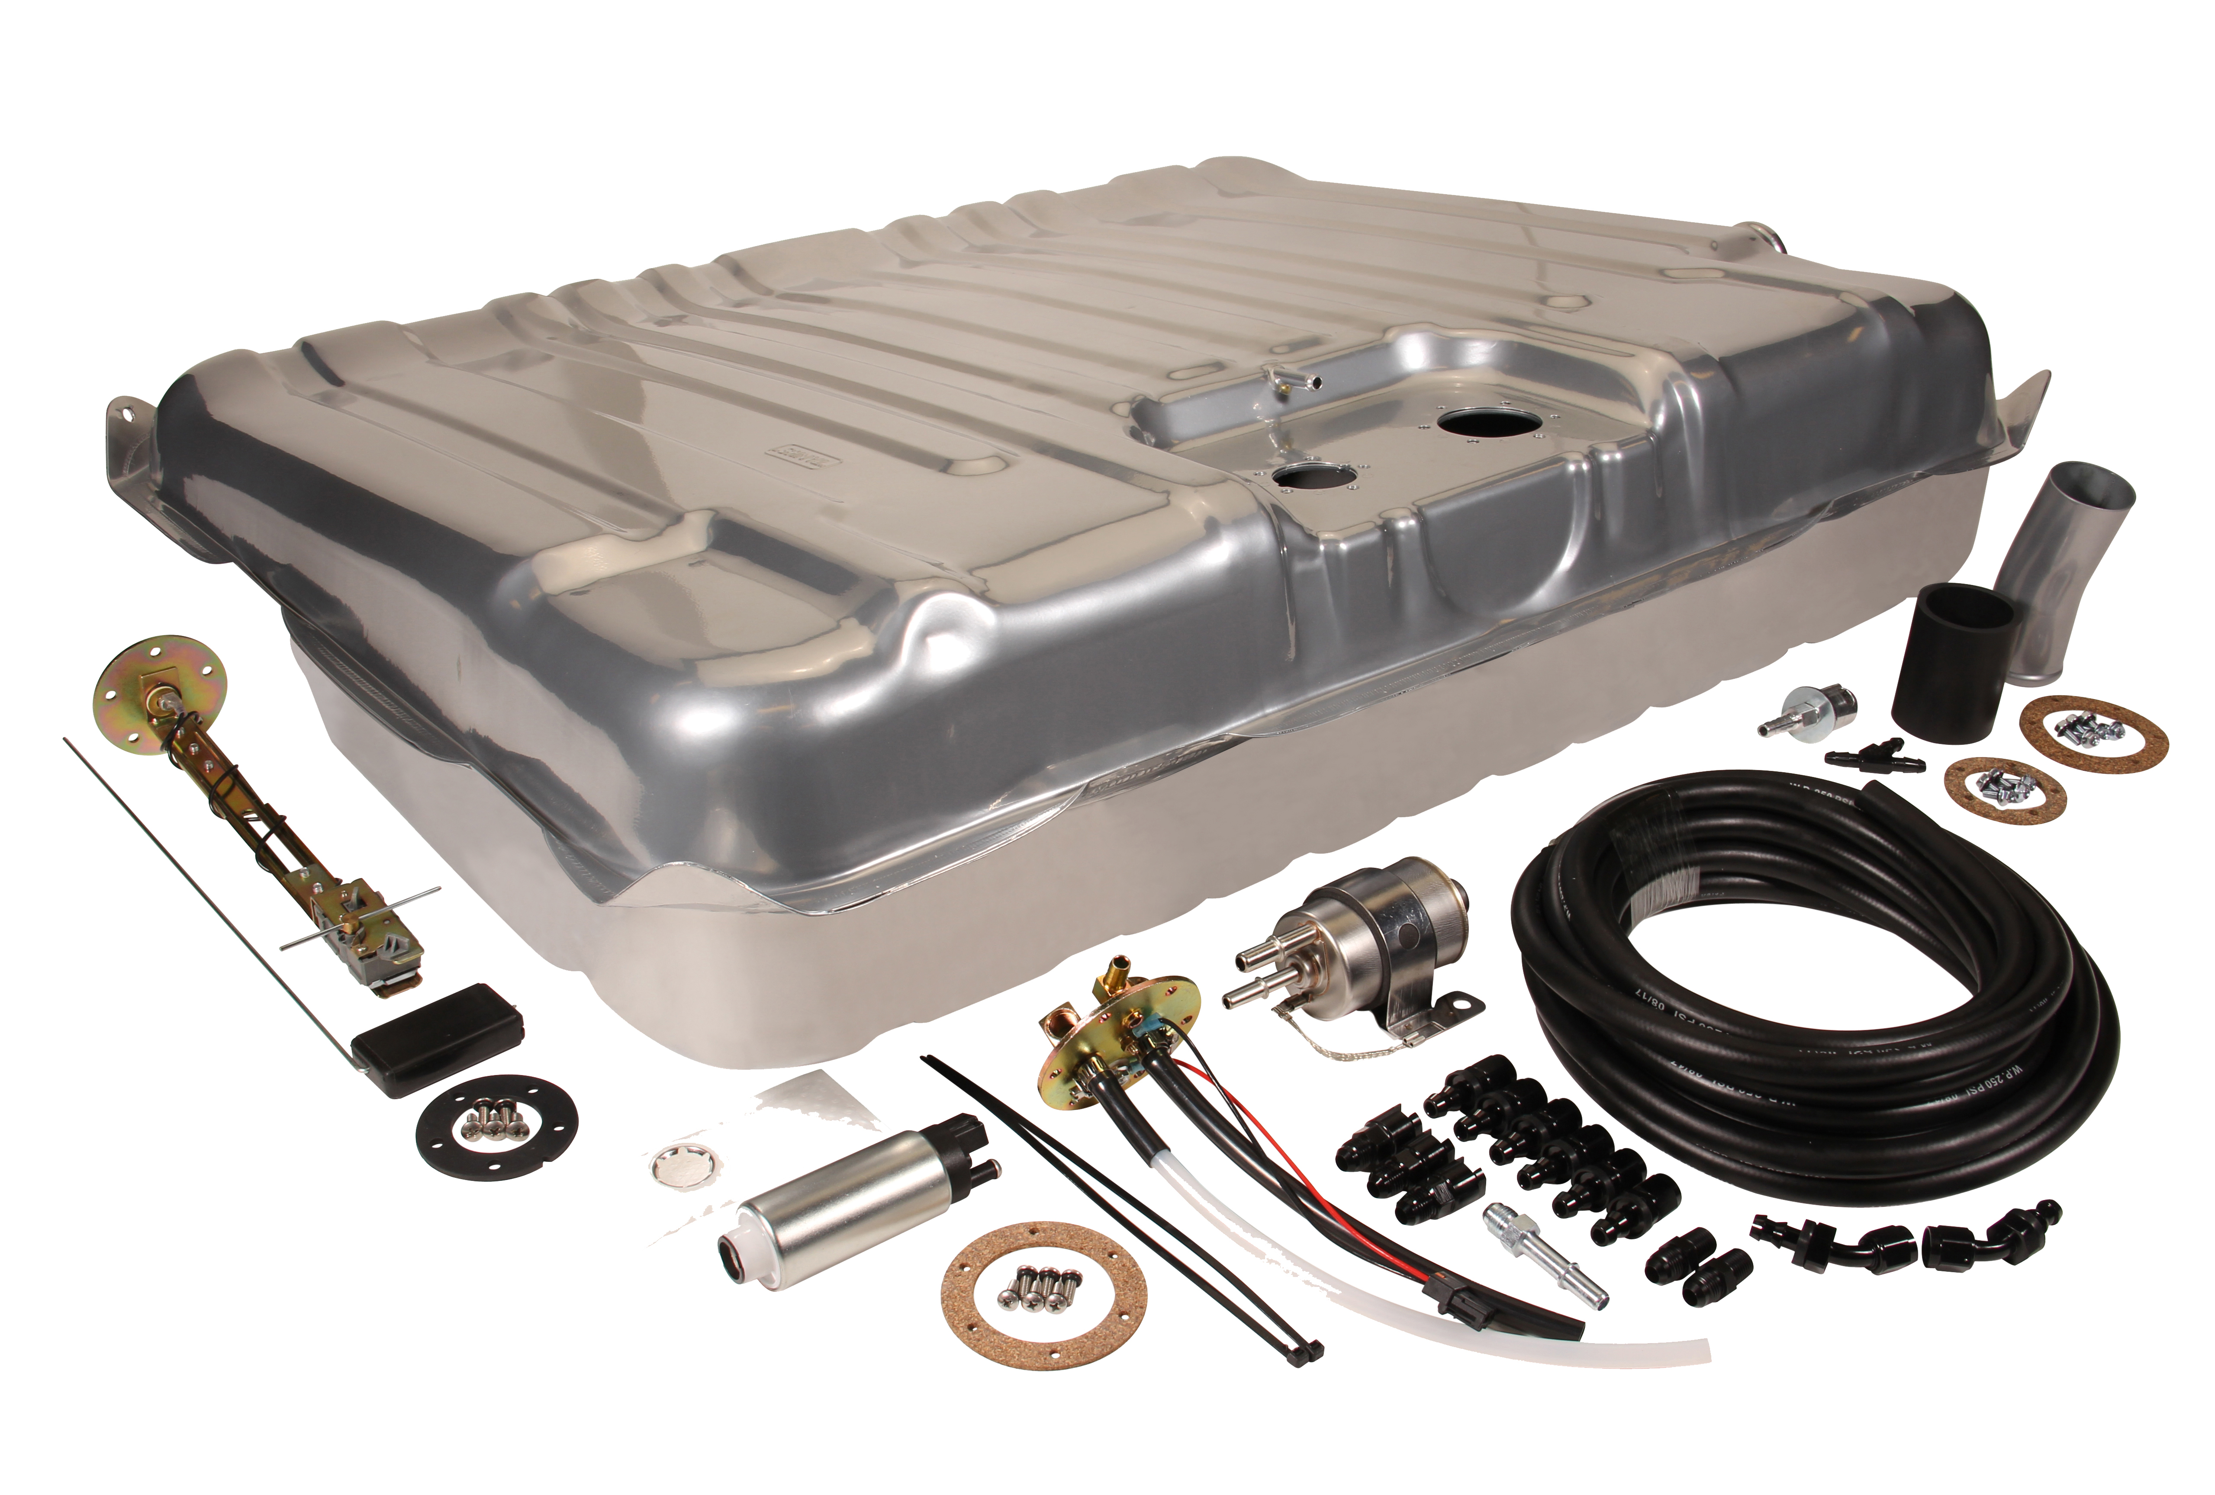
CLASSIC FIT ALL-IN-ONE FUEL INJECTION-READY TANK KITS
Our Classic Fit EFI All-in-One Fuel-Injection Ready Tank Kit is the most complete choice when adding a fuel injection-ready tank to your vehicle. Our kit includes an original fit tank with built-in fuel tray, a fuel tank sending unit and An fuel regulator/filter combined with the most complete EFI fuel line kit in the market. This EFI Fuel Line Kit comes with the fuel hoses and all the fittings to plumb from the fuel pump forward. All of our fuel fittings have a push-lock connect end that does not require specialty tools to disassemble. Our kit also includes a 255 l/h In-tank pump that supports up to 600 HP, or an upgraded high-volume pump option, with the proper install components. In-tank fuel pumps are much more efficient and run much cooler than running an inline pump. Contains all of the necessary pieces to mount to your vehicle.
Classic Performance Products, Inc. has been providing top quality steering, brake and suspension components for classic Chevy and Ford cars and trucks, as well as street rods, for over two decades. Call (714) 522-2000 and order a catalog today, featuring our complete line of parts and accessories.
# # # #

